**Create DataContext**

1- Create a Data folder in the project

Create a c# class named as DataContext.cs, which will inherit from DbContext class.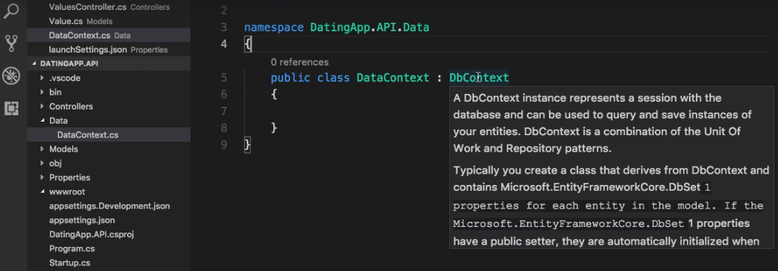

2- Adding entities classes as part of context

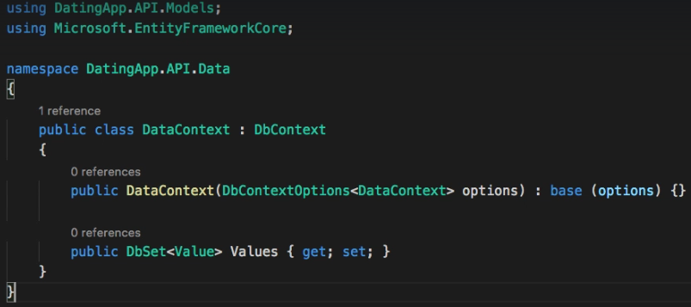

3- We now need to tell our application about the DataContext class and we do that in startup.cs class by adding below code. And we will need to download the MicrosoftEntityFrameworkCore.Sqlite package from nugget package manager console. 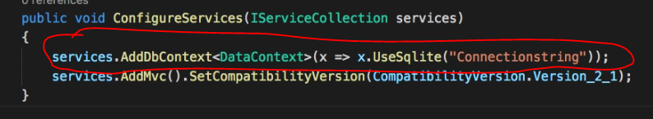

4- Now we need to add connection string in the appsettings.json file of the project.

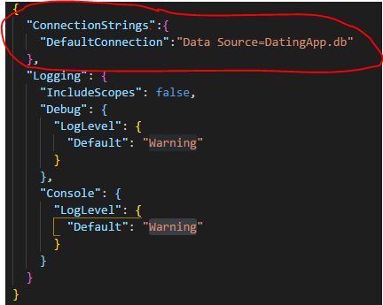

5- Now we need to make aware our application about this connection string so that it can read from the configuration file so in the startup file we modify the configuration services method

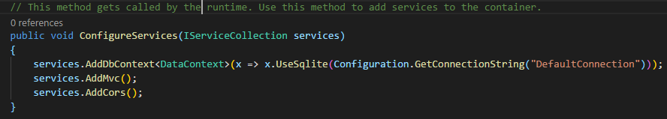

6- Now we need to use the Entity framework to scaffold and create our database, so in the terminal we type few commands



After executing the above command it will create a migration folder in the project.

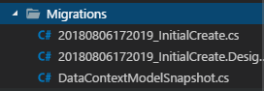

To create the database we need to execute the below command and once this is executed we will then have DatingApp.db as the database in project.



Once the database is created we can browse through it using the ‘DB browser for SQLLite’ tool.